Engage Deploy GUI

**Overview:**

The PowerShell Script (engage_deployment.ps1 ) does the Engage Deployment.

It accepts some parameters and does the work for us.

The GUI helps us gather these parameters and execute the command to execute the PowerShell script.

**Requirements:**

* Directory Structure:
  + Lucas Home = > C:\Lucas_Tools\EngageDeployment\
    - All the scipt and executables for the Engage Deploy should be here
      * EngageDeploy.jar ( GUI - written in Java)
      * engage_deployment.ps1 ( PowerShell Script )
      * engage_deployment_config.xml ( Configuration File )
  + LogHome = > C:\Lucas_Tools\EngageDeployment\Logs
  + Status Home for ongoing activity
  + C:\Lucas_Tools\EngageDeployment\Status
* Software Requirements
  + Install Java 8 (Java 1.8) as out GUI is written in Java

**Parameters Passed the Powershell Script:**

* Deploy By ->
  + -byPatchgroup : Flag to tell the script deploy by Patch Group
    - -patchGroup : if the above is true , patchGroup will carry list of patch Groups
  + -byDCID : Flag to tell the script deploy by DC
    - -DCID : if the above is true , DCID will carry list of DC IDs Selected from the list
* -deploymentType

“F” -> Full Deployment

“U” -> Uninstall Only

“I” -> Install Only

* -3Step

A flag, Its to mention a special case where the current version is installed first before proceeding with the selected Deployment Type

* -currentLucasSoftware

Current Lucas Build Name

* newLucasSoftware

Current Lucas Build Name

* clusterTarget

Passes the Name of the Server Targeted in a clustered/ Stand Alone Server

* status

Name of the status file that keeps track of the progress. At the end of the script execution the Status file is removed, that lets the GUI know that the triggered Script Execution is completed.

**GUI Components:**

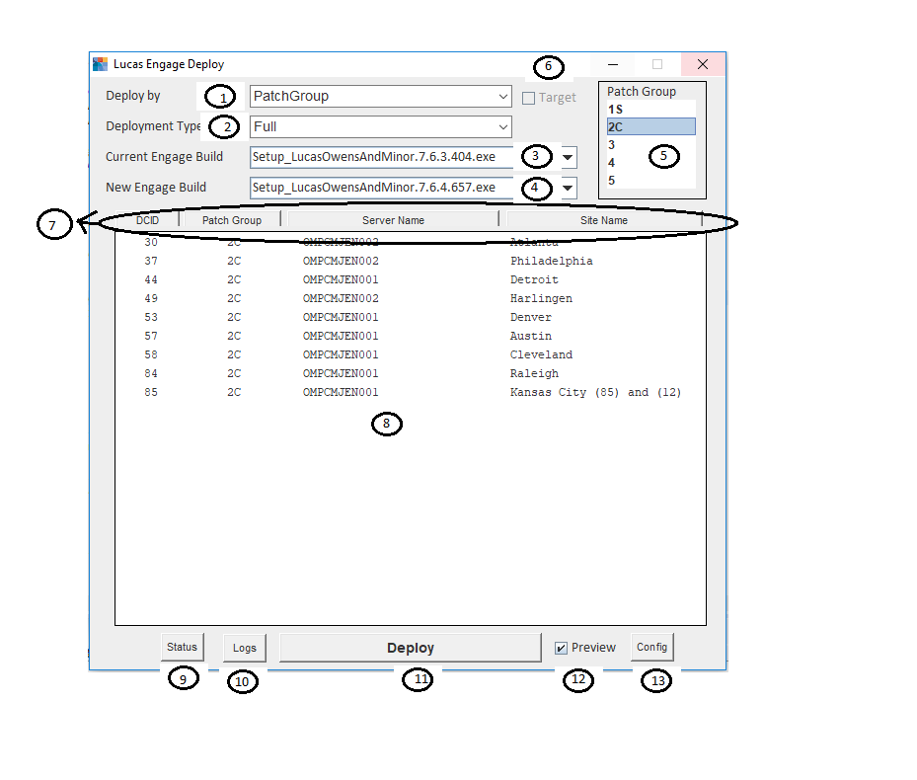

1. Deploy By
   1. PatchGroup 🡪 parameter -byPatchGroup
   2. DC Id -> parameter : -byDCID
2. Deployment Type : parameter -deploymentType
   1. Full -> -deploymentType “F”
   2. Install Only -> -deploymentType “I”
   3. Uninstall Only -> -deploymentType “U”
   4. 3Step => value : -deploymentType “F” -3step
3. Current Engage Build : parameter –currentLucasSoftware “Current Lucas Build Name“
4. New Engage Build : parameter –newLucasSoftware “New Lucas Build Name”
5. List to select the patch Group ID to be passed as the parameter –patchGroup “Selected Patch Group Id”
6. Targeted Checkbox to pass the targeted server name from a cluster/stand alone server
7. List header and sort button
8. List to display the DC details
9. Show the list of servers that has process/jobs running
10. Show the GUI application logs with the history of the commands executed with time stamp
11. Deploy the Script as per the selections made on the GUI, this will prepare the parameters and invoke the Command Promps server wise .
12. Will show the preview of the Commands executed before executing.
13. Show or update the Configuration File